My site has two site

1)customer website home.html

2)admin log in [Adminlogin.html](http://home.html)

Customer website

Contains home.html



There is page only have sign in and sign up



1)Click sign in or sign up

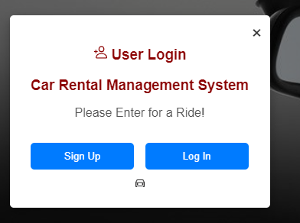

2)fill the detail and click register

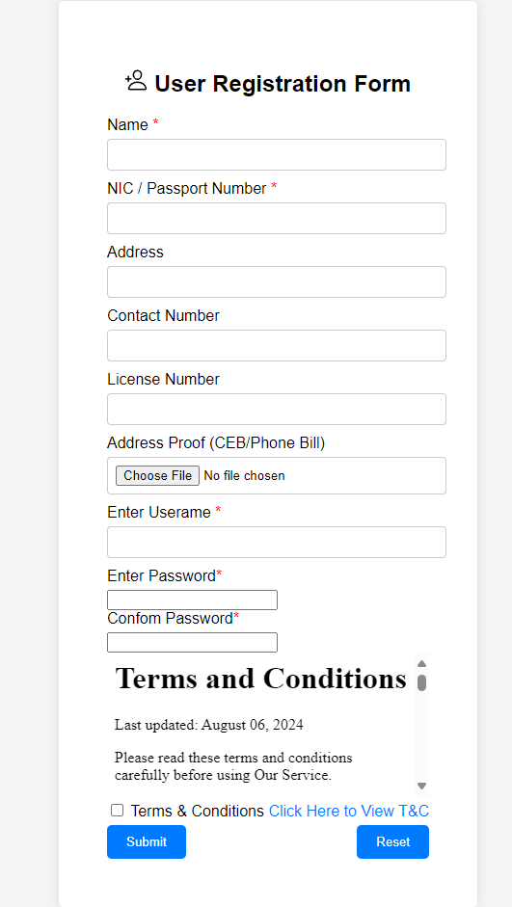

3)log in with the passwords

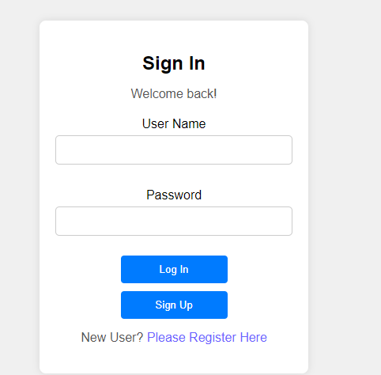

4)front view of customer page

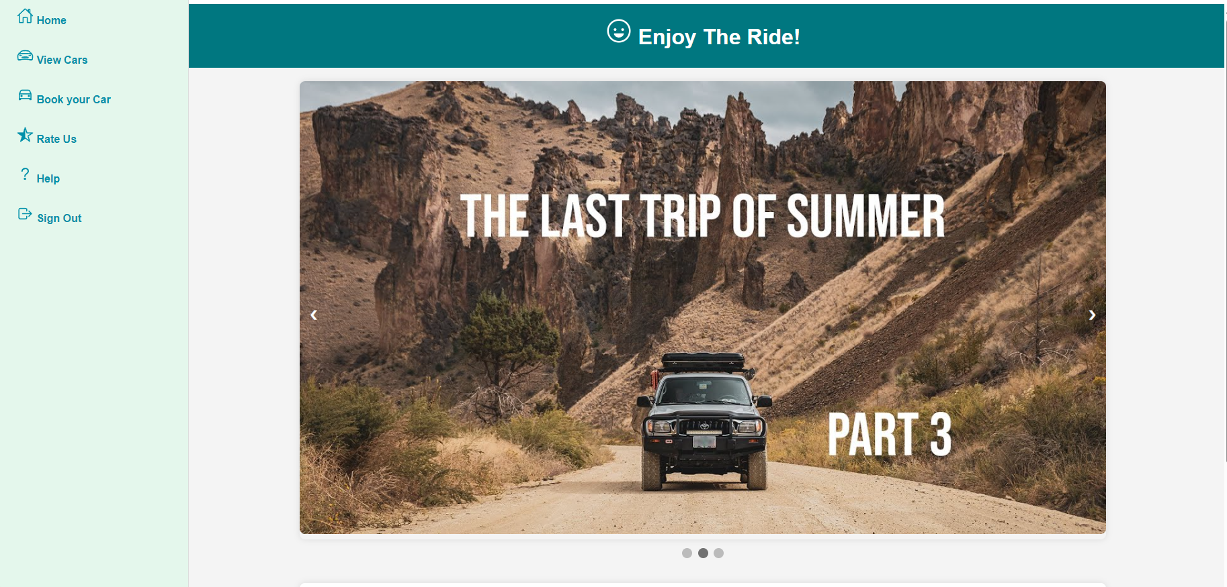

5)this has 5 lists



1-view cars

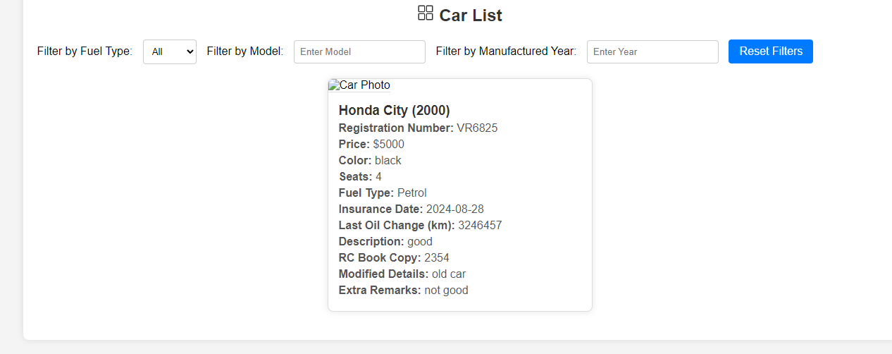

2-bookyour car

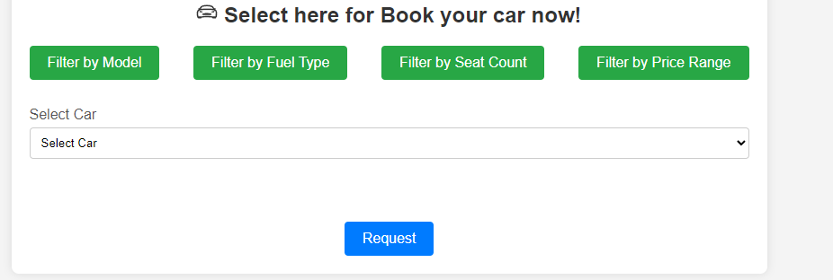

You can request to admin admin approved it

3-rate us contain feedback form

4-help contain terms and conditions

5-sign out go to web page home.html

Gaps

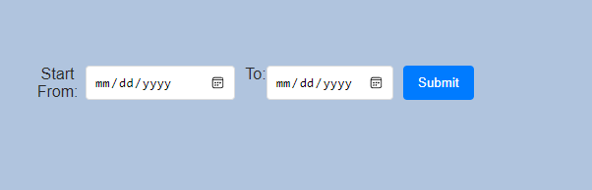

Under developing not working

In car details car photo is not display

2)Admin log in in [Adminlogin.html](http://home.html)

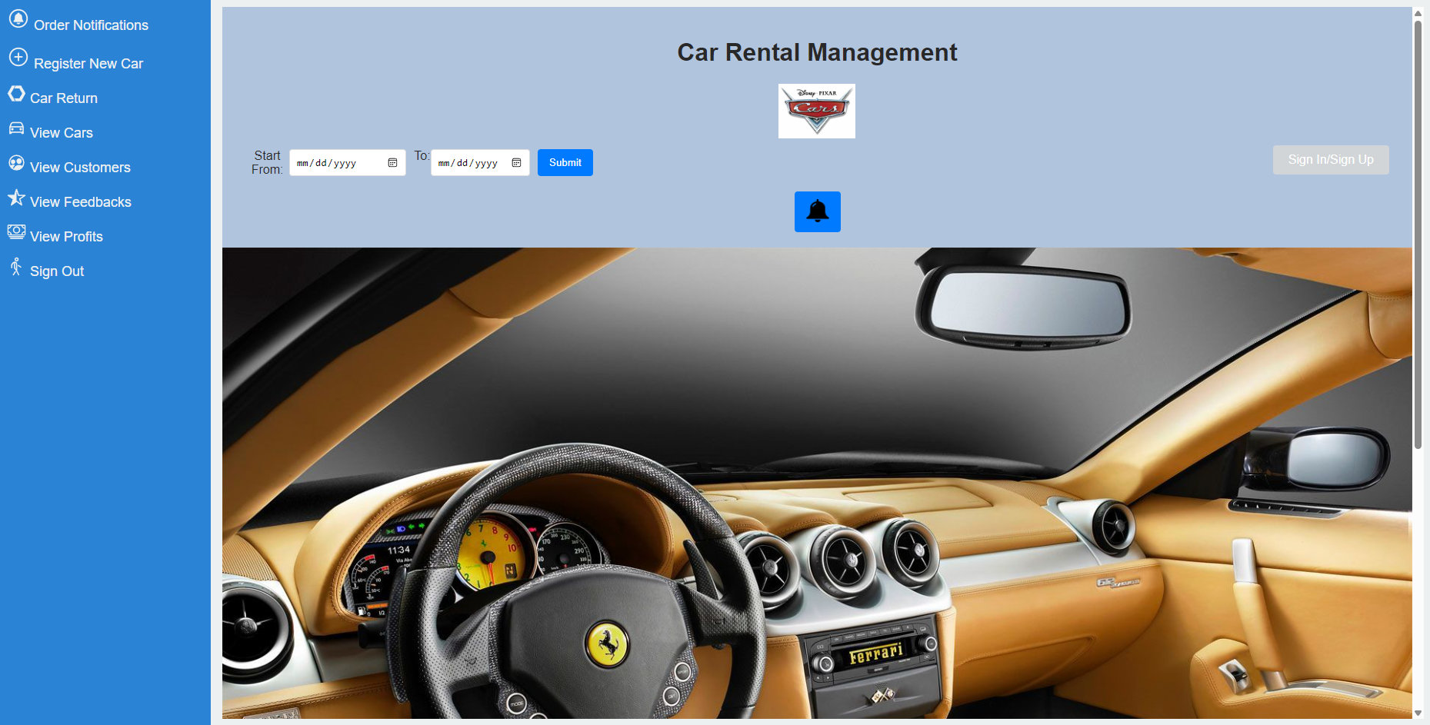

1)Order notification

It has pending approval requested by customer

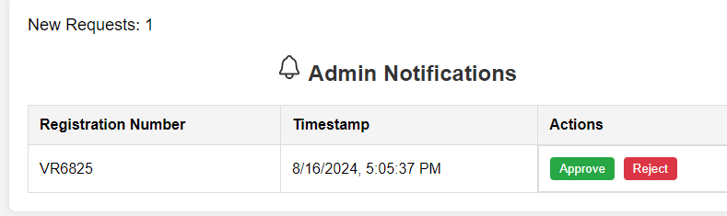

If approve car will be can rent

2)register new car

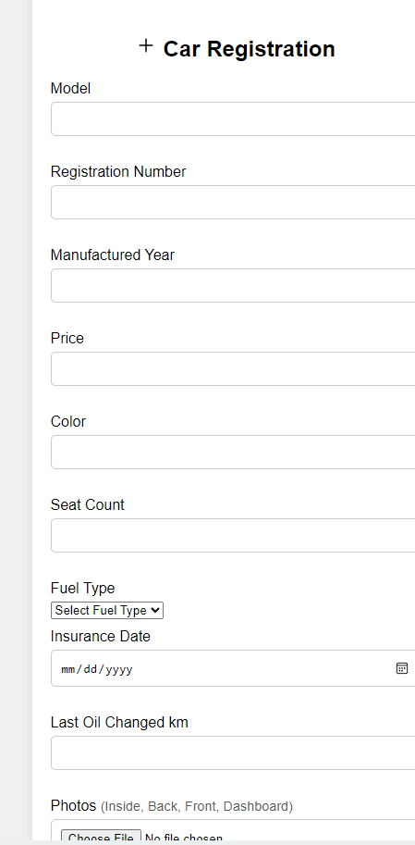

If register car would be add in car details

3)car return

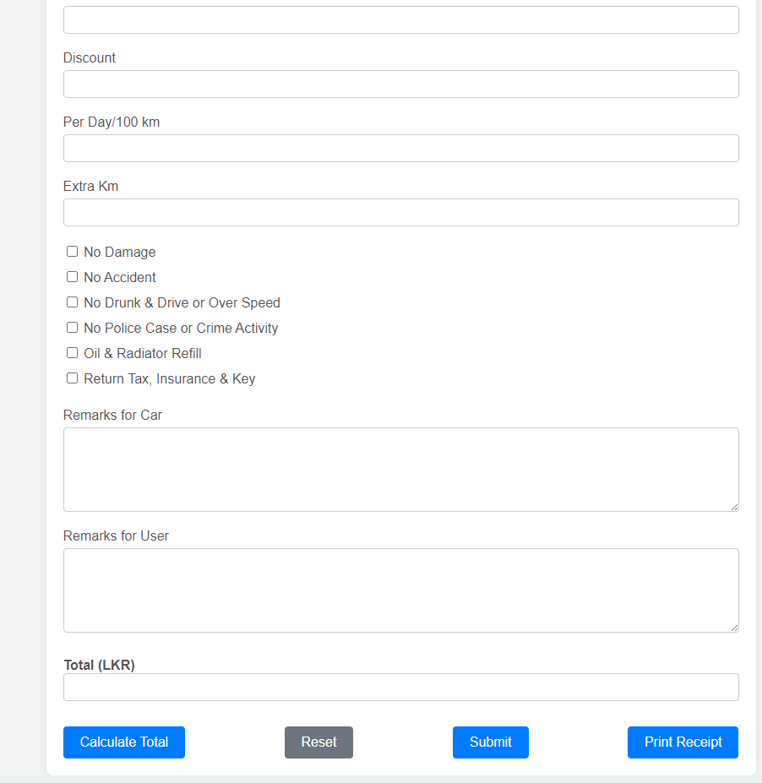

It should add by admin after seeing rented car

It would be calculate it

4)view cars

5)view customers

6)view feedback

Contains details about

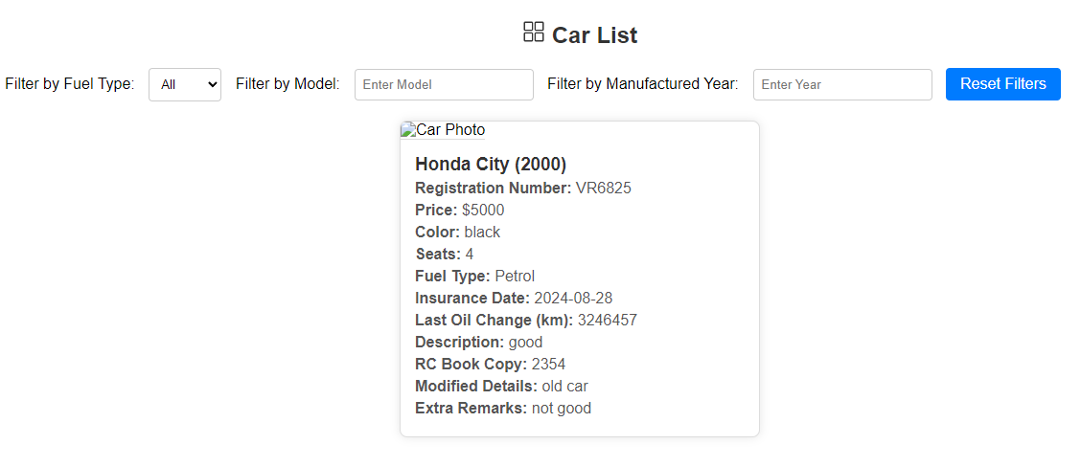

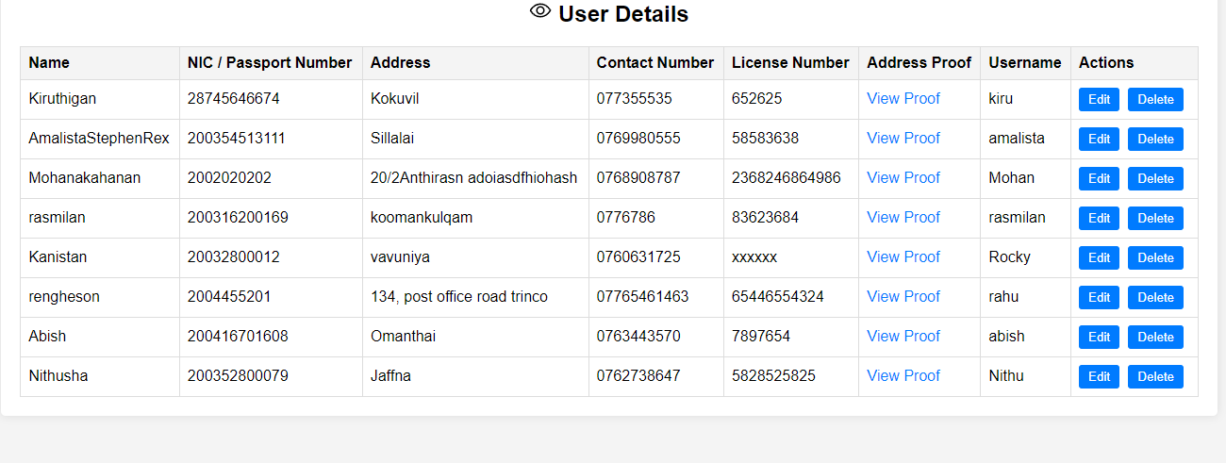

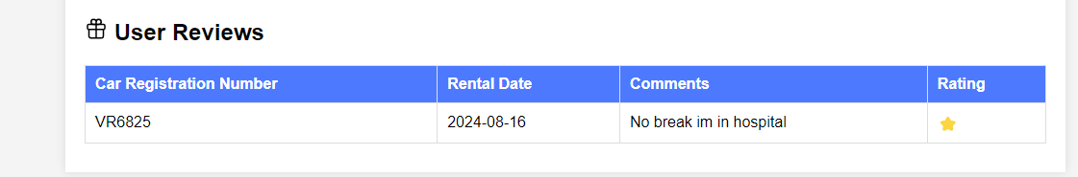

7)this is the reprt about profit

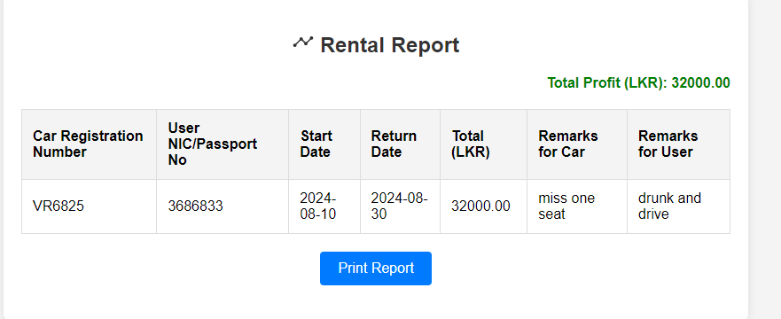

8)sign out back page to admin site

Gaps in admin site

Photos didn’t diplay error occurred

Customer detail can be delete but cant edit

**Thank you**